SPECIFICATIONS OF POLICE PENSION ADMINISTRATION
Pension on full retirement
(1) When a contributor retires—
(a) on the day before the day on which he or she attains the age of 55 years
or
(b) when he or she has 30 or more years of pensionable service,
he or she is entitled to a pension on full retirement at the annual rate set as outlined below except when the contributor makes an election under section 14 to take a reduced pension and gratuity (also see below).
Formula on Full Retirement
Annual rate of pension (paid in monthly installments)
An annual rate of pension payable to a contributor is the rate arrived
at when the following formula is applied—
R = 1/60 PY + 1/60 PS
where—
R = annual rate of pension
P = pensionable pay
Y = number of completed years of pensionable service up to 20
S = number of completed 6 month periods of pensionable service from 20½ to 30 years.

Reduced pension and gratuity on full retirement
(1) A contributor who makes this election shall be paid
(a) a reduced pension on full retirement at the rate of ¾ of the annual rate of pension
and
(b) a gratuity on full retirement in the amount arrived at when the following formula is
applied—
G = (¼ P ÷ 100) M
where—
G = gratuity amount
P = annual rate of pension set out in annual rate of pension formula
M = multiplier for the contributor determined under the schedule below

MULTIPLIER TABLE
Age of Contributor | Multiplier
50 & below | 1575
51 | 1575
52 | 1560
53 | 1550
54 | 1530
55 | 1510
56 | 1480
57 | 1450
58 | 1420
59 | 1395
60 | 1370

Pension on Early Retirement
A contributor is entitled to a pension on early retirement at the annual rate set out previously in annual rate of pension, when he or she retires by resignation or dismissal having 10 or more but less than 30 years of pensionable service, except when the contributor makes an election to take a reduced pension and gratuity.
A pension on early retirement shall be—
(a) deferred until the pensioner attains the age of 60 years; and
(b) paid in monthly instalments in arrears.
The calculation will be the same as full retirement however as mentioned above it will be deferred until attainment of 60 years.
Formula for reduced Pension and gratuity on Early Retirement
- a reduced pension on early retirement at the rate of ¾ of the annual rate

- gratuity on early retirement in the amount arrived at when the following formula is
applied—

G = (¼ P x 12½) D
where—
G = gratuity amount
P = annual rate of pension set out in section 12
D = discount rate for the contributor as determined below

Discount Rate Table

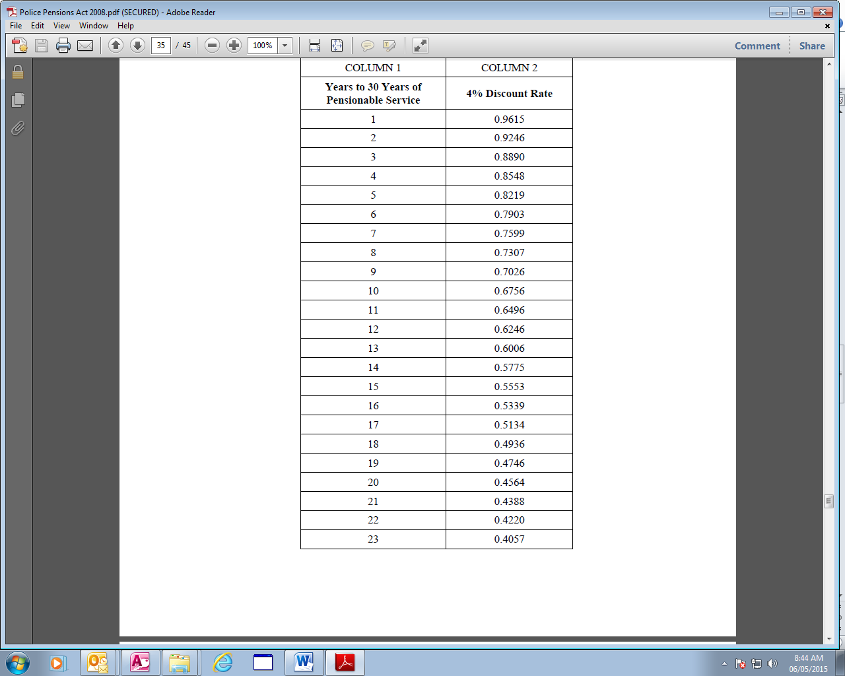

Formula for Gratuity for Short Service
Short Service: resignation or dismissal having 2 or more but less than 10 years of
pensionable service.

Pension for Short Service
Same as previous pension calculations. However the officer who resigns or dismisses on short service only has the option of (1) pension (deferred until age 60) or (2) Gratuity (formula provided below)
Gratuity for short service
A contributor who makes an election for short service shall be paid a gratuity for short
service in the amount arrived at when the following formula is applied—
G = (1/24 PS) D
where—
G = gratuity amount
P = pensionable pay
S = number of completed 6 month periods of pensionable service
D = discount rate for the contributor as determined using the discount table provided above.

